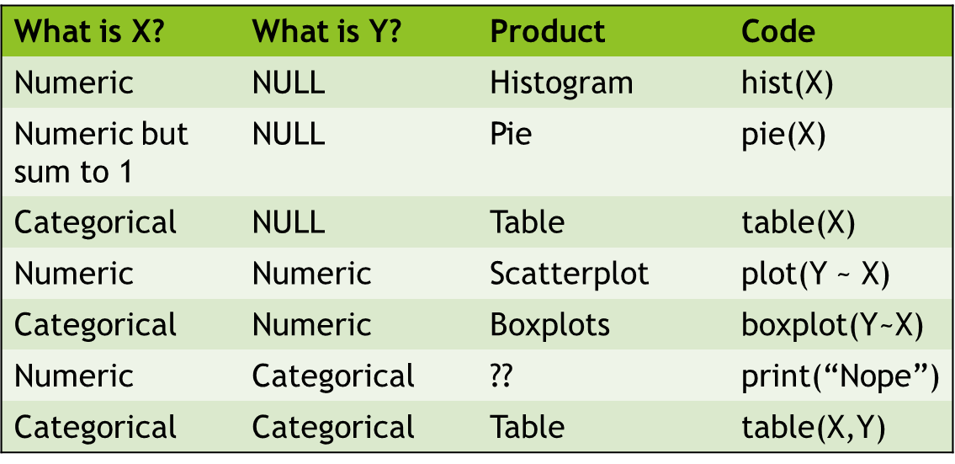

Problem: You want to explore a large data set that has all kinds of data types in it (categorical, proportional, and continuous). It’d be nice if you only needed to call one function to graph the data, regardless of what kind of data it was.

Goal: Make an “auto-plotting” function that will automatically detect what kinds of data you’ve given it and plot the appropriate graphic.

New Functions to know:

1. is.null(). Will return TRUE if the object given as input doesn’t exist (that is, it’s NULL).

2. is.factor(). Will return TRUE if object given as input is a “factor” (*i.e.* is “categorical”).

3. as.factor(). Will make the object given as input a factor if it isn’t one already.

4. The functions in the “code” section of the table above. The basic syntax of these functions is also provided there.

Steps to take:

1. Start with the function skeleton we showed you earlier in the class.

2. Make the two arguments of the function be “X” with no default value (so an X vector always has to be given) and a “Y” whose default is NULL. This way, if only one vector of data is given, the function will know that there isn’t supposed to be any Y data this time around.

3. Use if/else function calls to figure out what type of data was given as input and then plot the appropriate graph type.

4. Integrate one type of plot at a time! You don’t have to do try to get the function to plot everything in the table above all at once (or at all), but you can if you want to.

Function testing: Use the following code to make some “fake data” to see how well your function works. All of these data will be of length 20, so their lengths should match.

X.test1 = rnorm(20, mean=10, sd=2) #Makes random numeric data.

Y.test1 = rnorm(20, mean=4, sd=3) #Makes random numeric data.

X.test2 = sample(1:20)/sum(1:20) #Makes random numeric data that sums to 1 (*i.e.* proportions)

X.test3 = as.factor(sample(LETTERS[1:3], 20, replace=TRUE)) #Random categorical data

Y.test2 = as.factor(sample(LETTERS[4:7], 20, replace=TRUE)) #Random categorical data.